Core Java 8 & Development Tools Contents – Class Libraries

______________________________________________________________________________

Contents

Class Libraries

super
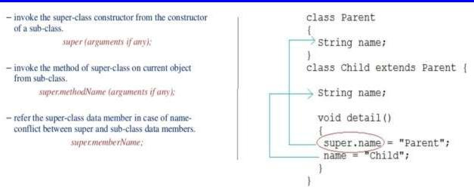

wrapper classes (immutable)

Simple Data types | byte, short, int, long, char, float, double, Boolean, void
Wrapper Classes | Byte, Short, Integer, Long, Character, Float, Double, Boolean, Void

Important methods of Integer class : intValue(), compareTo(), parseInt(), toString(), isNaN()

Type Casting

- Implicit type casting - Destination type is larger than source type

int a=5; float b; b=a;

- Explicit type casting – if there is a possibility of data class

int i = (int) (5.6/2/7);

1
Core Java 8 & Development Tools Contents – Class Libraries

______________________________________________________________________________

Scanner class

import java.util.Scanner;
-----------------------------------
Scanner sc = new Scanner (System.in);

int i = sc.nextInt();
System.out.println("You entered" + i);

String Handling

String handling methods : length(), indexOf(), substring(), trim(), valueOf(), isEmpty(), concat().

String Concatenation | concat()
StringBuffer Concatenation | append()

+ operator for String Concatenation :

String a = "hello"; int b = 3; int c = 7; String a = " world";

a + b + c -> hello37

a + (b + c) -> hello10

a + d -> hello world

2

